Perform Mathematical Operations With and Without NumPy

We are supposed to calculate the risk and store it as a column in the existing stock market dataset.
Without Numpy- Using the for loop
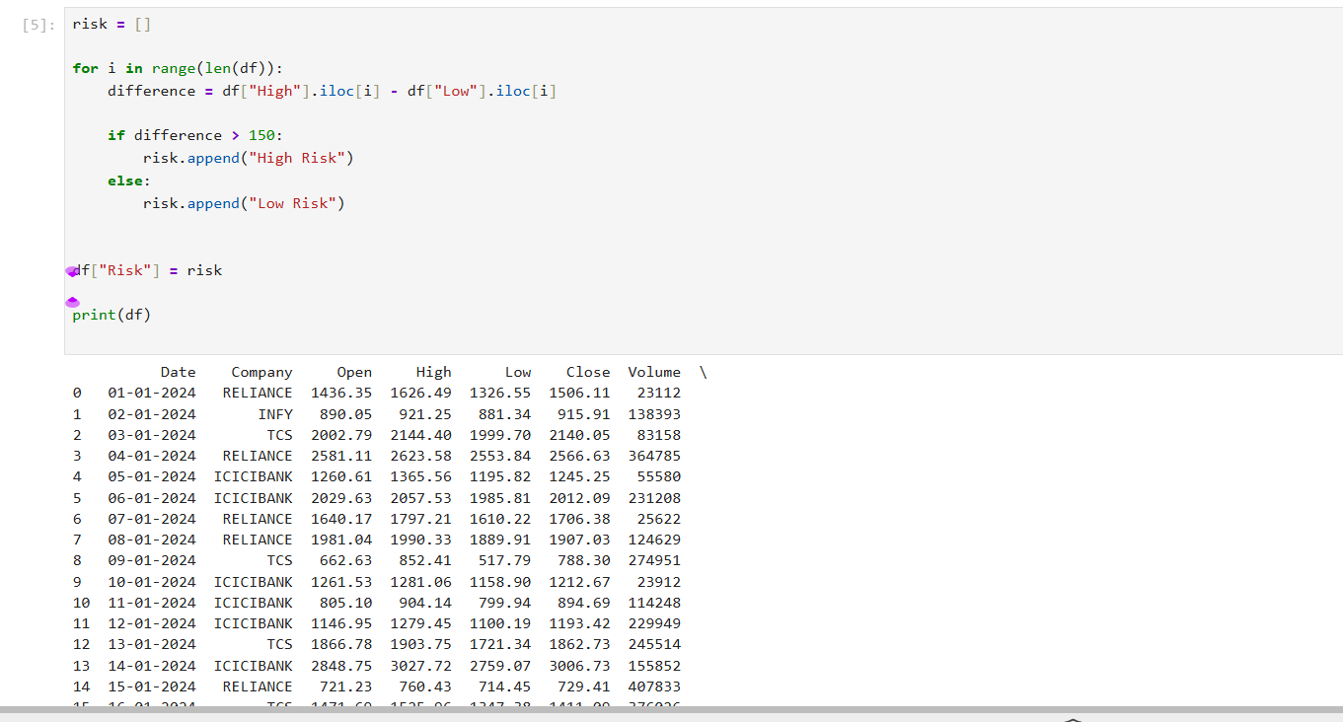
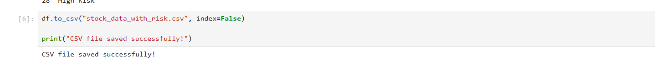
OUTPUT WITHOUT NUMPY
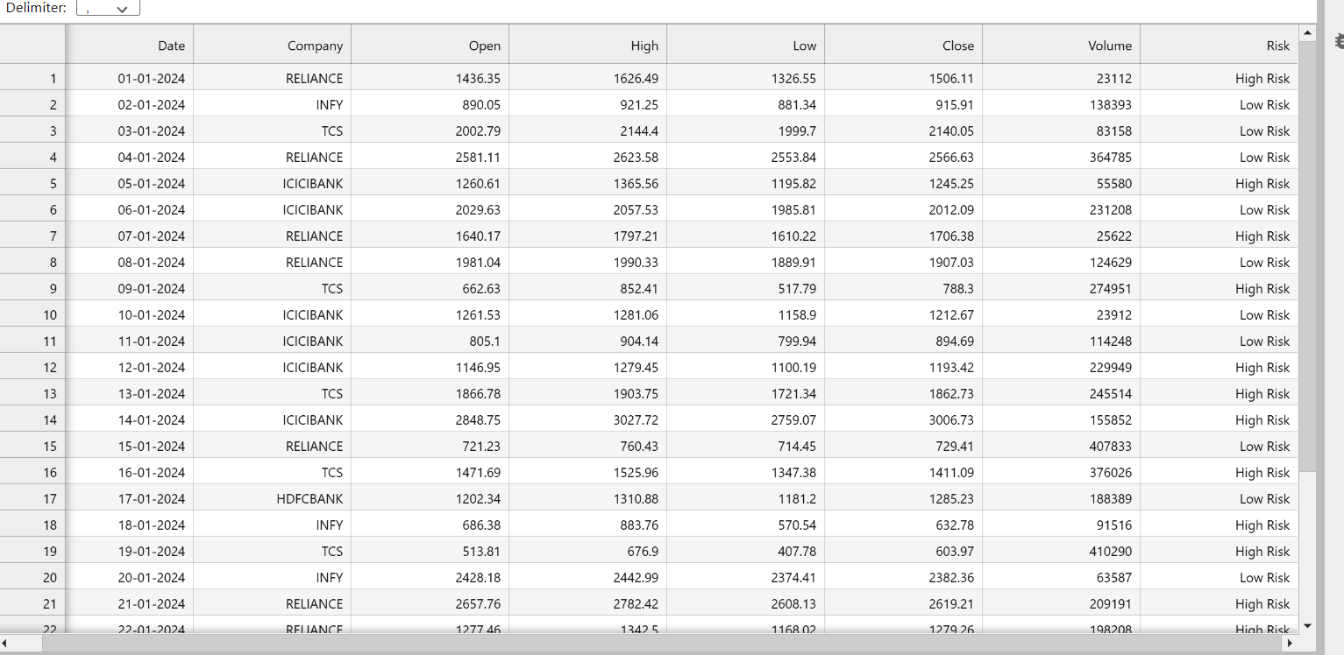

With Numpy
